Painful Partings

Helping Toddlers and Parents Cope with Separation Anxiety
by Katherine Bontrager
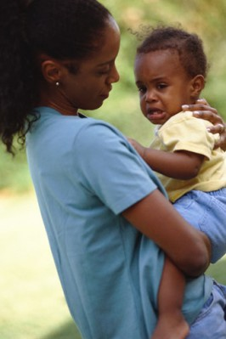
It's heartwarming when your little one adores you, clings to you and loves you above all else. But sometimes this stage can get pretty intense, to the point that Baby screams for anyone and everyone but Mom. It's exhausting and frustrating. Is there anything moms and dads can do to encourage the passage of this seemingly never-ending stage? How can moms learn to feel good about handing over a screaming child to another caregiver?
Parental Prep
"As a parent of one (and one on the way) and a former babysitter and daycare employee, I can tell you that the best thing a parent can do is trust that the child will stop screaming about five minutes after you leave the room," says Holly Chessman from Bedford, Mass. "It's important to understand that the child is not in any pain or real distress – he or she just wants the parent back. If you come back, then the child learns that screaming is the way to deal with the issue, and that doesn't bode well for anyone involved in the situation."
Chessman learned this truth early. "One of the babysitting jobs I had in college involved taking care of a 2-year-old while his parents were in another part of the house grading papers and doing graduate schoolwork," she says. "The first time I came to the house, the mother handed me her son and left the room. The boy started screaming and crying and the mother came running back into the room. After about the third time of sitting through this, I said to her, 'Please do me a favor. After you leave the room, no matter how much crying you hear, please just wait 10 minutes. If he's still crying at that point, feel free to come back in and we can see what we can do.' After some pleading, she finally agreed to this plan. Lo and behold, once the boy realized that Mommy wasn't coming back at the sound of his cries, he let himself be distracted and within five minutes we were playing happily together."
Chessman says that she's seen this scenario play out time and time again. "Sometimes it can even take longer than five minutes for the child to become acclimated," she says. "But if you're dealing with a competent caregiver and the parent is brave enough of heart to realize that the crying doesn't mean the child is actually being hurt in any way, then it will work its way out. In the end, the parent, caregiver and child will all reap the benefits of the situation."
It's just this sort of parental fortitude that Dr. Aaron Cooper, a clinical psychologist with The Family Institute at Northwestern University and co-author of I Just Want My Kids to Be Happy! Why You Shouldn't Say It, Why You Shouldn't Think It, What You Should Embrace Instead (Late August Press, 2008), recommends.
"How to feel good about handing over a screaming child to another caregiver?" Dr. Cooper asks. "It starts with attitude, with the right child-rearing philosophy. Millions of loving parents have signed on to the misguided approach: 'I just want my kids to be happy.' They've become a kind of Happiness Police, seeking out and thwarting anyone and anything that might erase the smile on a son or daughter's face."
It's a tough moment for loving parents – a child crying when handed over to another caregiver, Dr. Cooper says. "For the child, it's a moment of adversity," he says. "But good parenting recognizes that encounters with ordinary adversity, beginning in the toddler years, are a natural and vital part of childhood. It's how resilience develops, the all-important ability to ride out the ups and downs of life without falling off the horse. Parents will feel better about moments of tears and upset when they remind themselves that when children face adversity, it builds the emotional muscles they'll need for a lifetime."
A Tonic for the Tears

Parents can expect separation anxiety to kick into high gear as early as 9 months, says Christine Giguere, the founder and director of one of the oldest childcare establishments, Lexington Playcare Center, in Lexington, Mass.
And be ready for the long haul, because the stage can last until a child is 2 years old, says Susan Epstein, a licensed clinical social worker, parenting coach, owner of Parenting Powers and mother of two. "When a baby is born the infant has no sense of time," she says. "When the child begins to notice a parent's departure, the child experiences this as if the parent will never return. As the child develops a sense of memory, the child realizes that Mommy will come back, because she came back the last time."
But now that you're fortified against the tears, is there anything you can do to encourage the passage of this seemingly never-ending phase?
"Kids are all so different," Giguere says. "The relaxed, easy-going, anxiety-free type of kid needs almost nothing except a positive, happy parent who projects the feeling that s/he is going to have fun today. The nervous, timid, slow-to-warm-up child needs lots of prep. When these more anxious kids are very young, parents need to increasingly delay their response to their cries or demands. It's very hard to do, because our instinct is to respond very quickly to a child who cries with such intensity. However, even these kids can learn to wait 10 seconds while Mom or Dad finishes putting the milk in the fridge or 30 seconds while they finish a phone conversation. It's painful, but it's an investment in their future happiness."
Among Chessman's advice is to get your child accustomed to a regular sitter or caregiver from an early age. As well, don't hover when your child is playing with other children – this learned independence will serve everyone well. "The child needs to learn to make mistakes and develop enough independence that he or she doesn't need the parent to do everything," she says.
Chessman's own son has experienced this angst in what she calls a "recurring theme" typically brought on by major life changes. "Mostly I try to handle it in the way I would like other parents to handle it," she says. "I give him a big hug and say, 'I can't wait to see you when I come home! You'll have to tell me lots of stories of the exciting things you did while I was away, and I'll tell you exciting stories of what I did. See you soon!' And then I leave, even if he starts crying. If he's clinging to me, I ask the teacher or caregiver to help me out, and sometimes I wave to him through the window as I leave."
This experienced mom thinks it's important that her son sees her leave and hears a promise of her return. "I don't want him to be afraid that I will disappear unexpectedly, and seeing me depart lets him know that yes, I am actually gone, but I talked to him about it and I will return as promised," Chessman says. "I'll fully admit that it's heartbreaking to hear your child cry like that, especially knowing that if you come back, the child will stop crying and be happy, at least temporarily. But again, as long as I know he isn't really hurt or sick or in some kind of danger, I feel like it works better all around if I just leave. I may have to take a minute or two in the car [afterwards] to remind myself that what I'm doing is right! But it always works out fine in the end, and by the time I come to pick him up, he doesn't even remember that he had a fit when I left."
Epstein says avoiding the problem won't help matters. "Not leaving your child with a babysitter because you don't want her to cry or staying at daycare for an extra 15 minutes to settle her down will only exacerbate the problem," she says.
Giguere urges parents to get to know – and be very comfortable with – their caregiver, which will help with these angst-filled moments. "For most parents, it is impossible to leave their child with a stranger and feel good about it," she says.
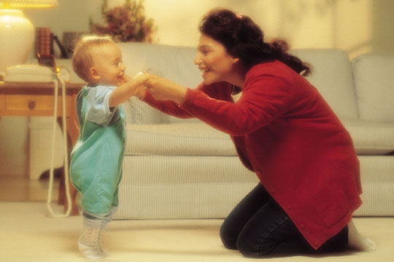
Giguere recommends several pre-visits to put everyone at ease. "Then, prepare the caregiver by providing comfort items (stuffed animal, blanket, photo of the family) and by letting her/him know that you expect an intense reaction and what strategies might help," she says. "Possibly most important of all is to develop a routine that is rock-solid predictable – do not vary. For example: Say good morning to the teacher, look at all the choices that are available that day, read a book, say goodbye and, tears or no tears, leave. Do not linger, do not say goodbye five times – go. Over time, the child will learn that s/he cannot control the adults and ultimately that is very comforting to children. All the work that parents have done before this moment will have been well worth the effort. The child will have already dealt with upset moments without an adult rushing in to make it better and s/he will have developed some coping and recovery strategies."
Parents should also remember that this will not last forever; in a few weeks' time their morning routine can change and parents can linger a bit, Giguere says. "So the rule of thumb is strict and short routine when the child is upset, loosey-goosey when the child is happy," she says.
And know that you can call and check in after you've left to make sure everyone has settled down. Giguere says that most daycare centers will call a parent if the child can't be distracted or comforted – so no child will be left to inconsolably scream for hours on end.
When you return, make sure you ask questions, Epstein says. "Ask, 'How long did he cry when I left this morning?'" she says. "The caregiver will most likely say 'Not long at all – one of the other kids arrived and he got distracted and he was fine the rest of the day.

Source:
http://www.toddlerstoday.com/articles/socializing/painful-partings-6032/#
date: 4/13/09

